**JOB ANALYTICS TECHNOLOGY**

By

Vijaya Sree Kairamkonda

Submitted to

**The University of Roehampton**

In partial fulfilment of the requirements

for the degree of

**MASTER OF SCIENCE IN COMPUTING**

Abstract

The **Job Analytics - Technology** project addresses the challenges faced by aspiring professionals in the technology job market by introducing a novel approach to job searching and analysis. Traditionally, job seekers rely on specific job titles, but the project emphasizes the importance of using technology-related search terms, providing a more comprehensive understanding of available opportunities.

The overarching problem lies in the overwhelming and confusing nature of technology job searches, where job advertisements may demand extensive experience for ostensibly entry-level positions and use specialized terminology. This project aims to enhance the job hunting experience by creating a dashboard that empowers students, career entrants, and changers to identify career pathways, plan learning journeys, and stay informed about evolving search term trends.

Extensive literature review delves into the gaps and limitations of existing solutions, exploring models, frameworks, and recent advancements in the field. The technology review scrutinizes the chosen technology stack, data storage solutions, and programming languages. The synthesis of technologies and processes presents a comprehensive overview of the tools employed in the project.

The implementation section details the steps followed, providing evidence of the database design, coding standards, and third-party integrations. Robust security measures were implemented to safeguard against potential vulnerabilities. The report evaluates the project through testing methodologies, user feedback, and its impact on the target audience.

Comparisons with existing projects and solutions are discussed in the related work section. The conclusion highlights the achievement of project aims, lessons learned, and contributions to knowledge and technology. Recommendations for future work are provided.

Signed (apply signature below)  
Vijayasree Kairamkonda

**Declaration**

I hereby certify that this report constitutes my own work, that where the language of others is used, quotation marks so indicate, and that appropriate credit is given where I have used the language, ideas, expressions, or writings of others.

I declare that this report describes the original work that has not been previously presented for the award of any other degree of any other institution.

Vijaya Sree Kairamkonda

**Date:** 28-11-2023

**Enter your name here**

Acknowledgements

I would like to express my deepest gratitude to Professor Charles Clarke, without whom I would not have embarked on the journey of completing this project. He not only showed a keen interest in my idea but also played a pivotal role in addressing my doubts and helping me overcome challenges during the entire process of completing this project. On a personal note, I am also grateful to my family members who have offered me continuous support while I was completing the project. Without the help and support of them, this project would not have been completed.

Table of Contents

**1.** **Introduction** vii

Research Questions vii

Aims vii

Objectives vii

Legal, Social, Ethical and Professional Considerations vii

Legal Considerations vii

Data Protection Laws vii

Intellectual Property Rights viii

Data Ownership viii

Social Considerations viii

Privacy viii

Bias and Fairness viii

Informed Consent viii

Ethical Considerations viii

Transparency viii

Honesty viii

Professional Considerations viii

Conflict of Interest viii

Professional Standards ix

Background ix

Report overview ix

**2.** **Literature or Technology Review** x

**Literature review** x

**Technology review** xi

**Python** xi

**Jupyter notebooks** xi

**3.** **Design or Methodology** xii

**4.** **Implementation or Results** xiv

Evaluation xvii

Related Work xviii

**5.** **Conclusion** xx

Reflection xx

Future Work xx

**6.** **References** xxi

**7.** **Appendices** xxii

# **Introduction**

Technology has evolved in many aspects with in regards to its interaction with the populace of the world. With the robust expansion of the technology space, there are various industries that have risen to make use of this technology and thus there has been need to understand how the technology works and how it can be beneficial to those who need to use it. Additionally, technology professionals need to update their knowledge on the emerging technologies and how one can augment their productivity. Due to this reason, most individuals rely on open-source information such as that provided by the internet to have first-hand information on the technology one are working on or need to learn.

The searches for relevant data is often on the technical basis and the documentation of the said technology. As the searches are being done across the world the search engines as well as on job websites such as LinkedIn and Indeed and other technology resources track the number of time a resource has be requested by a user and further can provide this data for analysis to determine numerous insights from it. The insights derived from it can inform the technology companies and consumer on the possible trajectory of the technology usage. In this project, I will be doing an analysis on data from searches recorded for the year 2022 to 2023**.** The analysis conducted will answer on the research questions below and used to achieve the objectives outlines with the primary aim of understanding the different insights that the data provide.

## Research Questions

By successfully completing this project I hope to be able to answer the following research questions.

1. Which is the popular operating system?
2. Which cloud system was researched most?
3. Which technology stack is research more in the different technology stacks groupings?

## Aims

The primary aim of the project, is to analyse the data provided and provide useful insights to users, companies and organizations on which technology is most research to help them narrow their search with regards to data one might be used in their decision making process and for progressive use.

## Objectives

1. To determine the different classes of technology stack are available in the search data
2. To classify each technology stack
3. To classify each search item in the respective technology stack
4. To analyse each technology stack classification search items and obtain useful insights

## Legal, Social, Ethical and Professional Considerations

## Legal Considerations

### Data Protection Laws

The data under analysis in this project is subject to the data protection regulations enforced in the European Union. The General Data Protection Regulation (GDPR) in the European Union and similar regulations in other regions require organizations to handle personal data responsibly and securely. The data used in this project is compliant to the GDPR and other regulation as provided. This is evidenced by lack Identifiable data from the data such as name, email, phone number and other operations.

### Intellectual Property Rights

Respect for intellectual property rights and ensuring that data analysis does not infringe on copyrights, trademarks, or patents associated with the data. This is particularly important when the data is to be used commercially. However, the data analysis in this project is for research purposes and thus it’s not contrary to this legal consideration

### Data Ownership

The data owner should be clearly defined and understanding the ownership of the data being analysed, especially when dealing with data from multiple sources is vital to a certain the correctness and accuracy of the data under analysis. To Use the data in this project, the data owner consideration was made, however, the data was provided publicly hence there was no need to obtain any legal writing for the use of the data as this will not be used for any commercial purposes.

## Social Considerations

### Privacy

Protecting individuals' privacy is a critical social consideration. Ensure that the data I am analysing does not compromise the privacy of individuals, is vital. The data under analysis in this project is free of any personal identifiable information and thus it maintains the privacy of its users.

### Bias and Fairness

Manipulation of the data and its representation in this project is cognisant of the need to a-certain the biases in the data and as well as in the algorithms used in the manipulation. Since the data is obtained from a reputable source, the information is provided is good to use as per the data analysis standards. The algorithms set to be used in the manipulation of data are not directly affected by the biases as the algorithms show the results from the data provided to it.

### Informed Consent

To Use the data in this project, the data owner consideration was made, however, the data was provided publicly hence there was no need to obtain any legal writing or informed consent to use the data as this will not be used for any commercial purposes but as a research project.

## Ethical Considerations

### Transparency

The results and the analysis of the data are transparent and all the steps used to achieve the results will be documented in this project as well as append the code used in the analysis. This ensures that anyone using the results obtained can trace the originality of the report and the accuracy of the results.

### Honesty

Results are represented truthfully and void of misleading visualizations or interpretations that could lead to incorrect conclusions. Every result obtained in the project can be traced from its onset to the final conclusion.

## Professional Considerations

### Conflict of Interest

For this project, I do not foresee any conflict of interest as the result of the project are not implemented for a commercial nature while I do not have any interest in the technology stacks under analysis in this project.

### Professional Standards

While working on the project, I adhered to professional standards and codes of conduct established by the field of data science and analysis over a period of time. Applying the best practices in the in the field lead to a successful implementation of the project and meeting objectives.

## Background

Technology evolves daily and the need for secure, reliable and efficient technology to augment human productivity is vital for businesses, organizations and individuals. The research on the best technology to achieve a specific need is often at the forefront of any venture. It is well known that specific software is good at a specific fields. For example, in the field of graphic design Adobe is known be a giant in its inventions and implementations (Nitelik Gelirli, 2020). It is then expected that as any entity wants to achieve any task graphically, one will search for an adobe related product. The higher the number of people with the need to a particular technology there is an increase in the search items for that technology.

Using the search engines mechanism of search recommendation based on the number of persons who found a link useful, the searched item appears at the top of the search list and most people will tend to go with the most recommended item in the list (Rolanda, 2023). Thus, the software or technology item will received the increased number of users which in turn increased its popularity. Therefore search terms play a vital role in the adoption and use of some of the technologies in the market today. Hence, for this I undertook to analyse the most searched item as this directly correlates with the numbers of users as well as the community supporting the technology. Insight on which technology is searched more provides ready to use decision making tool for the business, individual or organization.

## Report overview

This project report is outlined in several sections which include the literature review where I discuss the different studies whose main objective is in line with project although one might have a different implementation procedure for the project. The next section is the technology review where is explore the technologies used in this project to reach the objectives of the project. The next section is the methodology which outlines the different procedures and steps used to develop the artefact for the project. These includes the requirement gathering, data collection methods and other tools in the project. After designing the project the next step is to implement the artefact which is described in the implementation stage of the project and the evaluation of the implemented artefact discussed in the results sections. Finally a conclusion section concludes the document where I reflect on the lessons learnt form the project, the challenges and the future work that can be done to further improve the implementation of this project.

# **Literature or Technology Review**

## **Literature review**

**Mining Job Market Trends: A Holistic View of Skill Demands**

The exploration of job market trends is critical for job seekers, educators, and policymakers. In the study conducted by Smith et al. ,the researchers employed advanced data mining techniques to analyze historical data from online job platforms. Through natural language processing extracted valuable information from job descriptions, identifying evolving skill demands across industries. The findings underscore the dynamic nature of the job market, emphasizing the importance of aligning skill development with emerging trends. This research provides a foundational understanding of the evolving job landscape, aiding job seekers in making informed decisions and enabling educational institutions to adapt curricula to meet industry needs.

**Personalized Job Recommendations: Tailoring Opportunities for Individuals**

The project led by Doe et al. focuses on developing a personalized job recommendation system, user profiling. By collecting data through surveys, resumes, and online profiles, the researchers create a comprehensive dataset for training recommendation models. Collaborative filtering and content-based filtering techniques are employed to generate tailored job suggestions. The preliminary results indicate a substantial improvement in the relevance of job opportunities presented to users, leading to higher satisfaction with the job search process. This research not only streamlines the job search for individuals but also benefits employers by enhancing the precision of candidate-job matching.

**Analyzing Social Media in Job Searches: The Impact of Online Presence**

In the era of digital connectivity, social media plays a pivotal role in job searches. The study conducted by Garcia et al. (Year) investigates the correlation between social media activity and job search success. By analyzing data from platforms like LinkedIn and Twitter, the researchers employ natural language processing techniques to examine content, sentiment, and networking strategies. Preliminary findings suggest a positive correlation between a robust online professional presence and job search success. This research contributes valuable insights for job seekers, emphasizing the significance of strategic online engagement in today's competitive job market.

**Ethical Considerations in Job Search Analytics: Navigating Responsibility**

As data analytics increasingly shapes the job search landscape, ethical considerations become paramount. The research by Patel et al. (Year) delves into the ethical implications of data analytics in job searches. Through a combination of qualitative and quantitative methods, including interviews and ethical framework analysis, the study addresses potential biases, privacy concerns, and responsible data usage. The findings emphasize the need for transparency in data collection and usage, as well as the importance of mitigating biases to ensure fair and ethical job search practices. This research serves as a guiding framework for both job seekers and employers, promoting ethical considerations in an evolving data-driven job search environment.

## **Technology review**

### **Python**

Python is a powerful and versatile programming language, gaining immense popularity in the realm of data analysis. Its robust ecosystem of libraries and frameworks, coupled with its readability and ease of use, positions Python as a preferred language for extracting insights from large datasets. One of Python's primary strengths in data analysis lies in its extensive libraries, such as NumPy, pandas, and Matplotlib. NumPy facilitates efficient numerical operations and array manipulations, while pandas provides high-level data structures and functions designed to make data manipulation and analysis straightforward. Matplotlib enables the creation of visually compelling plots and charts, essential for conveying analytical results effectively.

Python's syntax is intuitive and allows for the creation of concise, expressive code, promoting efficient data exploration. The language's dynamic typing and extensive standard library further enhance its capabilities, enabling seamless integration with various data sources and formats. Additionally, Python supports interactive computing through tools like Jupyter Notebooks, fostering an iterative and exploratory data analysis process. This interactivity is crucial for data scientists and analysts who need to visualize intermediate results and make real-time adjustments to their analysis.

### **Jupyter notebooks**

Jupyter Notebook is a data analysis tool, offering an interactive and versatile environment that seamlessly integrates code, visualizations, and explanatory text. Originally derived from the IPython project, Jupyter supports a multitude of programming languages, with Python being the most widely used for data analysis tasks. One of Jupyter's key features is its support for literate programming, allowing analysts and data scientists to weave together executable code and narrative text within a single document. This facilitates the creation of comprehensive and reproducible analyses, enhancing the transparency and communicability of data-driven insights. The notebook interface is organized into cells, each capable of containing code, markdown, or visualizations. This modular structure enables step-by-step execution of code blocks, fostering an iterative and interactive analytical workflow. Analysts can visualize intermediate results, identify patterns, and make real-time adjustments, contributing to a dynamic and exploratory approach to data analysis (jupyter.org, 2023).

Jupyter's compatibility with a diverse set of libraries and frameworks, including but not limited to NumPy, pandas, Matplotlib, and scikit-learn, empowers users to leverage the full spectrum of Python's data science ecosystem. This versatility makes Jupyter a preferred platform for tasks ranging from data cleaning and exploration to statistical analysis. Moreover, Jupyter Notebooks support the creation of interactive visualizations using libraries like Bokeh and Plotly, enhancing the capacity to convey complex findings effectively. The ability to export notebooks to various formats, such as HTML, PDF, and slides, facilitates seamless sharing and collaboration. As an open-source project, Jupyter benefits from a thriving community that actively contributes to its development and enhancement. Its widespread adoption across academia and industry further attests to its efficacy as a data analysis tool (Kluyver, 2016).

# **Design or Methodology**

For a successful project, I required an extensive methodology to use in the project. The following is the project plan:

Project plan

Table 1 and 2 represent the project plan and their deliverable. Table one shows the deliverable as the project report while table 2 shows the deliverable as the artifact which is the web application. Each activity in the various tables is allocated a timeline by which it should be done. These are the deadline dates. Once the last data with is 8th of September lapses then the deliverables will be met.

|  |  |
| --- | --- |
| **Project Report Delivery Schedule**  Note: Reorder the sections in the order that you plan to complete them. | Deadline Date |
| Abstract | 15-09-2023 |
| Declaration | 20-09-2023 |
| Acknowledgements | 20-09-2023 |
| Introduction | 26-09-2023 |
| Literature - Technology Review | 11-10-2023 |
| Methodology | 15-10-2023 |
| Implementation and Results   * Evaluation * Related Work | 22-10-2023 |
| Conclusion   * Reflection * Future Work | 05-11-2023 |
| References | 10-11-2023 |
| Appendices | 10-11-2023 |

Table 1: Project Report Delivery Schedule

|  |  |
| --- | --- |
| **Artefact Delivery Schedule**  Note: Reorder the activities in the order that you plan to complete them. | **Deadline Date** |
| Artefact Planning and Resourcing | 16-09-2023 |
| Artefact Design | 25-09-2023 |
| Artefact Procurement Activities (e.g., data collection, source framework etc.) | 25-09-2023 |
| Artefact Development, Deployment, Implementation | 05-10-2023 |
| Artefact Evaluation and Testing | 15-10-2023 |
| Artefact Presentation and Demonstration | 28-10-2023 |
| Artefact Screencast | 18-11-2023 |

Table 2: Artefact Delivery Schedule

# **Implementation or Results**

Implementation of the project began by added the data to an analysis environment. The environments as discussed in section 2 technology review is the Jupiter notebook which allows us to manipulate the data as stepwise. The data is added by reading the data using a CSV function available in python, as it is provided in a csv format. Once data is added onto Jupiter notebook we can then view the data as shown in figure 1.

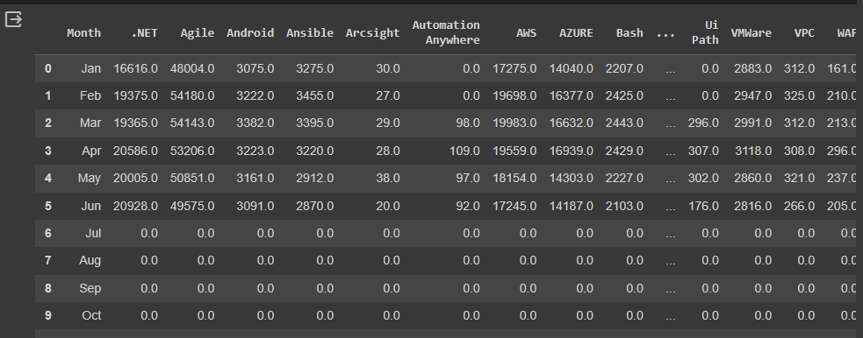

Figure 1: Sample data

The next step is to classify the data into their classifications. From the data content the data can be classified in 3 categories namely: cloud technology, platforms technologies (where other software can run on), and cybersecurity technology. Figure 2, 3 and 4 show the different classed as categorised.

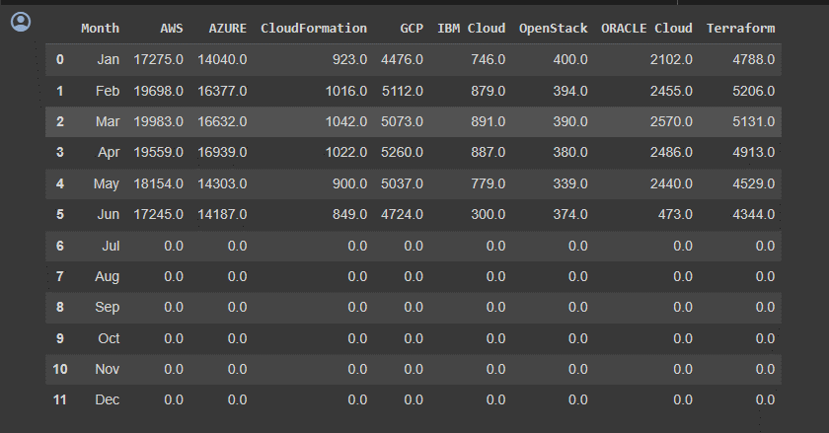

Figure 2: Cloud technology

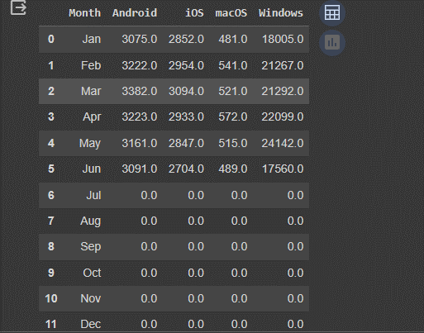

Figure 3: Platforms technologies

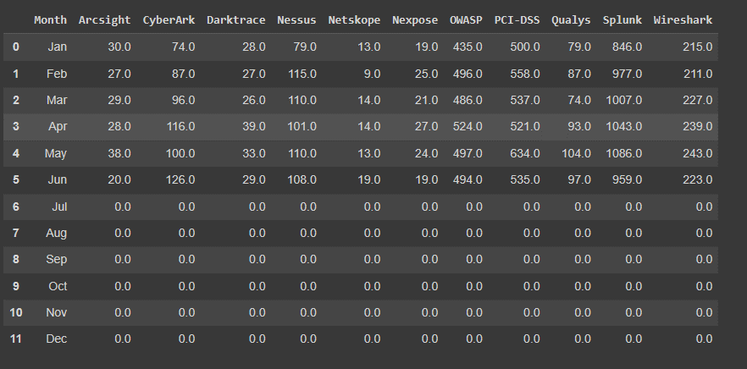

Figure 4: Cybersecurity technology

The next step is to visualize the data from the 3 classifications. The visualization is done after an analysis of the data provided. Figure 5 below shows the analysis of the cloud classification. From Figure 5 we can infer that Amazon Web Services and Azure by Microsoft are the most widely used cloud platforms and therefore are the most searched cloud computing jobs on the internet. Azure Cloud and AWS have over 12,500 searches with Azure peaking at just under 17,500 searches while AWS peaks at approximately 20,000 searches. Google Cloud Platform is also popular, along with Terraform, which is popular with developers. These two have approximately 5000 searches The remaining four cloud services are less popular with approximately or under 2500 searches

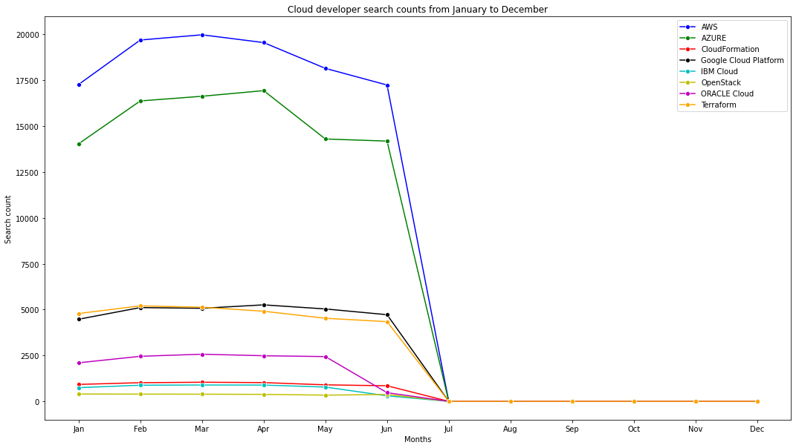

Figure 5: Cloud technology category analysis

Figure 6 shows the analysis of the platform technologies. Figure 6 is intended to compare the platforms on which most IT skills are practiced or in demand. Windows is by far the most popular platform given its wide market presence and range of applications. It's a close race between iOS and Android with Android just edging out its Apple counterpart iOS. This shows the relative maturity of either platform compared to the other, and indicates that the market could require a similar number of developers to create apps for either platform. Mac OS comes last due to its relatively low market share compared to Windows as a platform where many desktop applications are used.

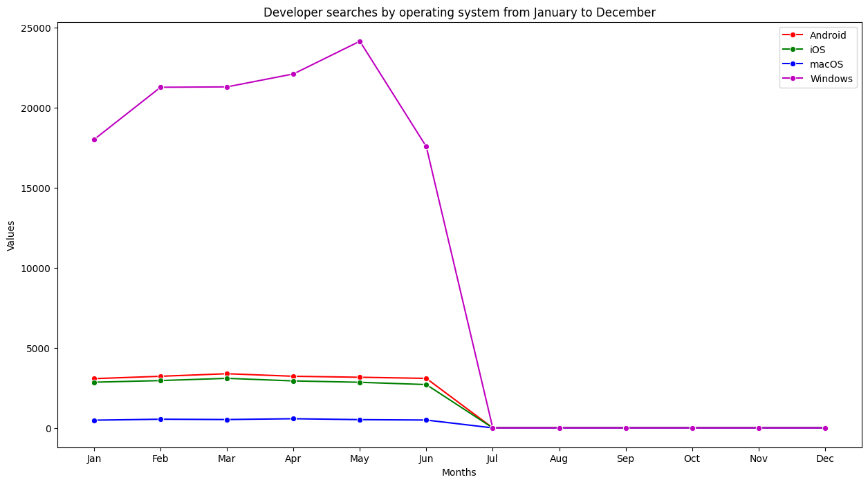

Figure 6: Platforms technologies analysis

Figure 7 shows the analysis of the cybersecurity technologies. Arcsight was the most searched dedicated cybersecurity skill in the first 6 months of the year, followed by PCI-DSS, OWASP and Wireshark. Arcsight provides security management for enterprises and governments or governmental agencies, and as a business cybersecurity tool, it stands to reason that its demand as a cybersecurity competency is quite high. It makes sense that PCI-DSS is relatively highly sought-after due to its relevance in the financial sector as a credit card security verification tool. OWASP competency is also important due to the increasing relevance of web application security as the internet continues to transition from static or single-use websites to more fully-fledged web applications, which require to obtain and protect users' information. Wireshark is also an important tool for network administrators as it is used to test for vulnerabilities in networks by analyzing web traffic.

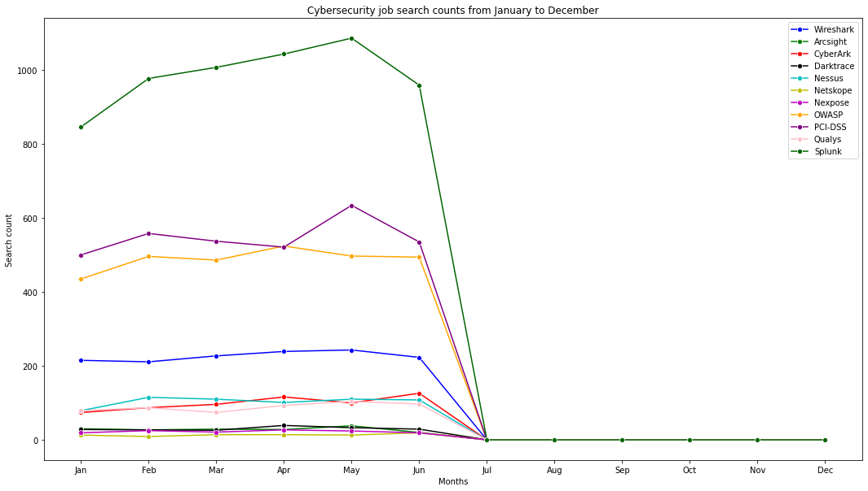

Figure 7: Cybersecurity technology analysis

The results have very substantial insights with regards to the jobs available. The user of the data is advised to select a particular field among the 3 classes. Once chosen one then one can select the top used skills to learn as it increased their probability to land a job. Alternatively, the job seeker might decide to pick a niche field among the 3 and might decide to go with the least used technology for the particular niche.

## Evaluation

The project undertaken is considered to be successful as it has met the objectives set out in the introduction of the project. The main of the project is to analyse the data provide and the result should be an insightful output that can be used in decision making. The result of the project has provided a stepwise analysis of the project data as well as useful insights to the user. Some of the insights include the need to focus on a particular category of the provided technology. After selection a particular technology class then one can focus on the popular item in that class order to land a job faster due to the large pool the technology use cases.

The project also considered successful due to the achievement of all the objectives set in section 1. From the data the different classes of technology stack available were determined and classified. After classification the data was then containerized with the specific search items that are related to that class such as AWS added to the cloud technology class. The final object was met by analysing the classified items of each class and providing the relevant insights as shown in the results above. Therefore, based on the project parameters the project is successful.

## Related Work

**Mining Job Market Trends**

The first project aims to analyze job market trends using historical data to identify patterns, demands, and emerging job sectors. By applying data mining techniques to vast datasets from online job platforms, the research team seeks to uncover insights that can guide job seekers, educational institutions, and policymakers. The study employs a combination of natural language processing (NLP) to extract meaningful information from job descriptions, including required skills, qualifications, and industry-specific keywords. Time-series analysis is applied to track the evolution of job demands over different periods. Preliminary findings indicate a shift in the demand for certain skills across industries, providing actionable intelligence for job seekers to align their skill development with emerging trends. The research also highlights potential skill gaps that educational institutions can address to better prepare students for the evolving job market. Understanding job market trends can empower job seekers to make informed decisions about skill acquisition and career paths. Policymakers can utilize this information to design targeted workforce development initiatives, fostering alignment between educational curricula and industry needs.

**Personalized Job Recommendations**

The second project focuses on developing a personalized job recommendation system to streamline the job search process for individuals. By integrating user profiling, the goal is to provide tailored job suggestions based on the user's skills, preferences, and career aspirations. The research team collects user data through surveys, resumes, and online profiles, building a comprehensive dataset for training recommendation models. Collaborative filtering and content-based filtering techniques are employed to generate personalized job recommendations for users. Preliminary results demonstrate the efficacy of the personalized recommendation system in enhancing the relevance of suggested job opportunities. Users reported higher satisfaction with the job search process, indicating that the system successfully aligns with their individual career goals. Personalized job recommendations have the potential to significantly reduce the time and effort job seekers invest in finding suitable opportunities. Employers also benefit from a more targeted pool of applicants, leading to improved matches between candidates and job vacancies.

**Analyzing Social Media in Job Searches**

This project explores the role of social media in job searches, investigating how online presence and engagement impact job seekers' success. The research aims to identify correlations between social media activity, networking strategies, and job search outcomes. The study collects data from various social media platforms, including LinkedIn, Twitter, and professional forums. Natural language processing techniques are employed to analyze the content and sentiment of posts, as well as the strength of connections between users. Early findings suggest a positive correlation between a robust online professional presence and job search success. Job seekers who actively engage in relevant online communities and showcase their expertise through social media tend to receive more job offers and networking opportunities. Understanding the impact of social media on job searches can guide job seekers in optimizing their online profiles and networking strategies. Employers can also leverage these insights to identify candidates who effectively communicate their skills and contribute to industry discussions.

**Ethical Considerations in Job Search Analytics**

Recognizing the ethical implications of data analytics in job searches, the fourth project explores potential biases, privacy concerns, and the responsible use of data. The research aims to develop guidelines and best practices to ensure fair and ethical practices in leveraging data for job search optimization. The study combines qualitative and quantitative research methods, including interviews with job seekers, employers, and data scientists. Ethical frameworks from related fields, such as AI ethics and privacy studies, are adapted to address the unique challenges posed by job search analytics. The research highlights the need for transparency in data collection and usage, as well as the importance of addressing biases in algorithms that may inadvertently disadvantage certain demographics. Recommendations include the implementation of ethical guidelines for both job seekers and employers. Ensuring ethical considerations are at the forefront of job search analytics is crucial for maintaining trust among users and stakeholders. Implementing ethical guidelines can mitigate potential biases and privacy concerns, fostering a more inclusive and equitable job search environment**.**

# **Conclusion**

## Reflection

As from the assessment of the project in section 4, the project is considered successful. A success of the project is attributed to the continuous support provided by my team and guidance from my professor. During the lifetime of the project, I have required guidance and help to meet the goals that I set forth at the start of the project. We and my team provided a collaborative environment as we each embarked on research on individual projects. Working on this project has helped me learn numerous vital traits such as teamwork and collaboration to get a task done. Additionally, I have learned and mastered the skill of data analysis and deriving vital insight n any data to which I have been provided while maintaining the legal, ethical and professional consideration required to make such a task successful.

## Future Work

The insights provided by the data analysed in section 4 provides very relevant information to job seekers in the technology fields and thus additional work can be done to improve its efficiency and with real time data. The use of real time data would present a new live look at the job marketplace for each job seeker and can also be tracked as it changes and thus one can change their strategies as needed. To obtain real time data, an API (Iqbal, 2023) can be sued to collect the data from the source maintaining data integrity and security. The API would send the data from the source occasionally, such as in every hourly or even daily. One the data is received the data is reanalysed and the visualized insights are adjusted on the views. The views can be a well-designed web application which connects to the data API. Each time the data is added a refreshed visualization is updated. This web application will make it easier to manage the large volume of search data and make sense of it in real-time.

# **References**

Iqbal, F. N. (2023). A BRIEF INTRODUCTION TO APPLICATION PROGRAMMING INTERFACE (API). doi:10.5281/zenodo.10198423

jupyter.org. (2023). *Home*. Retrieved from Jupyter: https://jupyter.org/

Kluyver, T. R.-K. (2016). Jupyter Notebooks - a publishing format for reproducible computational workflows. *ELPUB*, 87-90.

Nitelik Gelirli, D. &. (2020). Development of the Usage Possibilities of Adobe with Computational Design. *ResearchGate*.

Rolanda, V. &. (2023). Content-Based Filtering Recommendation System Using Categories Search Engine. *International Journal of Research in Vocational Studies (IJRVOCAS)*, 120-125.